Sprint 1

|  |  |
| --- | --- |
| **Team ID** | PNT2022TMID51856 |
| **Project Name** | Industry-specific Intelligent Fire Management System |

# Sprint 1 – CODING

#include <WiFi.h> #include "DHT.h" #include <Wire.h>

#include <LiquidCrystal_I2C.h> #define DHTPIN 15

#define DHTTYPE DHT22 #define LED 2

#define BUZZER 4

LiquidCrystal_I2C LCD = LiquidCrystal_I2C(0x27, 20, 4); DHT dht (DHTPIN, DHTTYPE);

void setup()

{

**Serial**.begin(115200); dht.begin(); pinMode(LED,OUTPUT); pinMode(BUZZER,OUTPUT);

digitalWrite(LED,LOW); digitalWrite(BUZZER,LOW); delay(10); **Serial**.println(); wificonnect(); mqttconnect(); LCD.init(); LCD.backlight(); LCD.setCursor(0, 0);

LCD.print("Connecting to "); LCD.setCursor(0, 1); LCD.print("WiFi "); delay(1000);

LCD.clear();

}

void loop()

{

LCD.setCursor(0,2); LCD.print("Smoke: "); LCD.setCursor(0, 0); LCD.print("Temp: "); LCD.setCursor(14, 0); LCD.print("C"); LCD.setCursor(0, 1); LCD.print("Humid: "); LCD.setCursor(14, 1); LCD.print("%");

h = dht.readHumidity();

t = dht.readTemperature(); f = random(0,1023);

if (f>300)

{

**Serial**.print("Smoke: "); **Serial**.println("Detected"); digitalWrite(LED,HIGH); digitalWrite(BUZZER,HIGH); LCD.setCursor(7, 2); LCD.print("YES");

}

else{

**Serial**.print("Smoke: "); **Serial**.println("Not Detected"); digitalWrite(LED,LOW); digitalWrite(BUZZER,LOW); LCD.setCursor(7, 2); LCD.print(" NO");

}

**Serial**.print("temp:"); **Serial**.println(t); LCD.setCursor(7, 0); LCD.print(t); **Serial**.print("Humid:"); **Serial**.println(h); LCD.setCursor(7, 1); LCD.print(h);

}

# Sprint 1 Output – Display Values is LCD

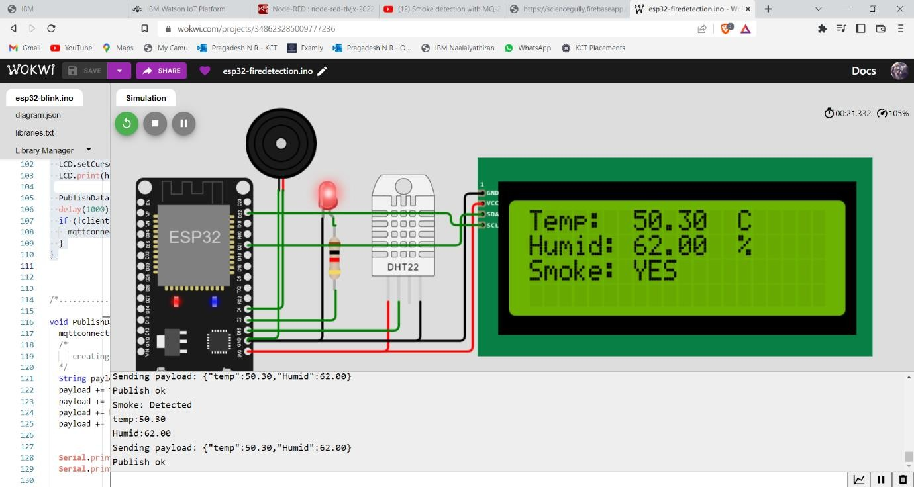

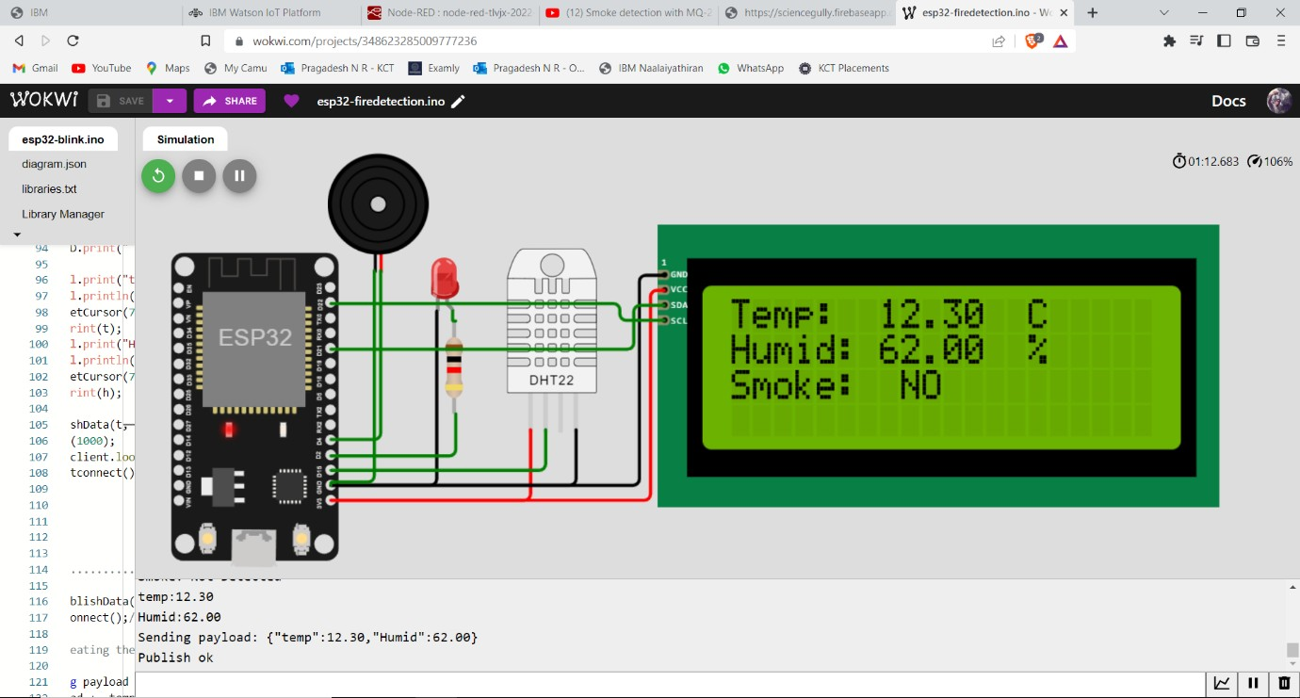

**For Smoke sensor random Analog-values are generated for ADC range from 0 to 1023.**

# Workwi Link: https://wokwi.com/projects/348623285009777236